**Thonex Market Study**

**October 2021**

1

**Summary analysis &**

**Geographic delimitations**

**Summary analysis & Geographic delimitations for the project under study**

1. **A micro view on the Thonex area (Thônex Switzerland)**

# Project presentation and General Data

1. Main demographic tendencies : Population, revenue range, familly types, single, ect
2. Real Estate Market : profile tendencies, sales and renting
3. Innovative services and features on new real estate projects
4. Specialized residences : ageing people, students, hotels, coworking, ect.
5. BtoB & BtoC buying trends (google trends, ect)

# A macro analysis to guide decision making on the different real estate markets within a 35 km radius of Thonex (including an analysis of cities located in France and Switzerland)

# Main demographic tendencies

# Economic forecasts

# Typologies of the real estate markets to be analyzed:

# Logistics

# Residential

# Retail

# Hotel

# Industrial

# Car parks

# Thonex Switzerland

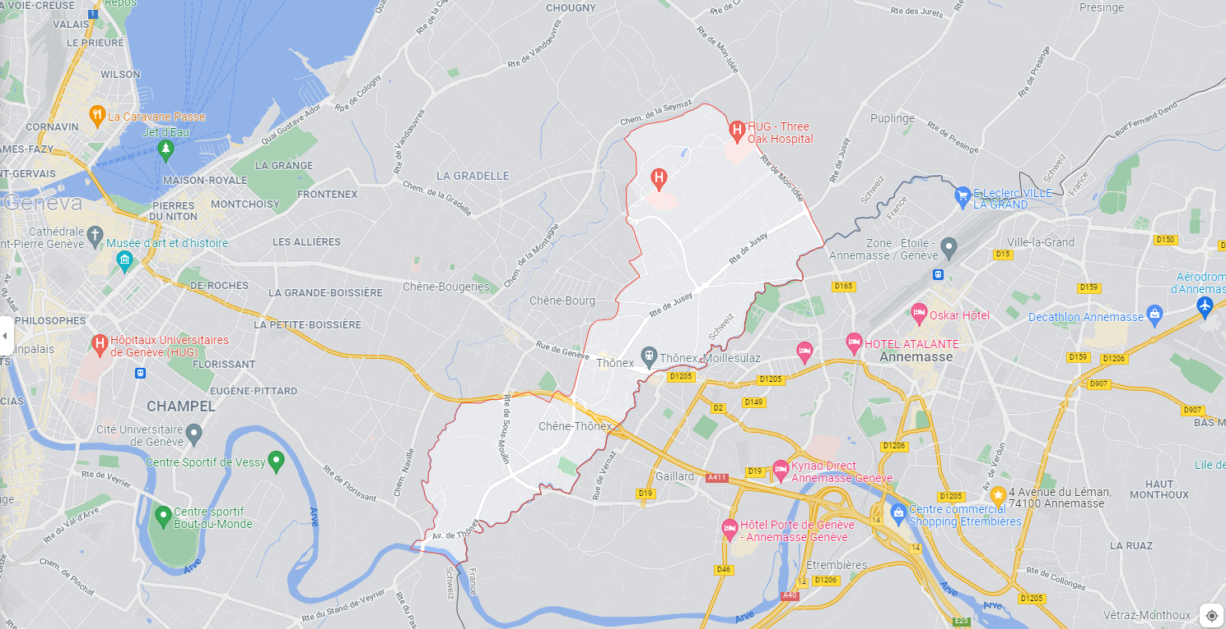

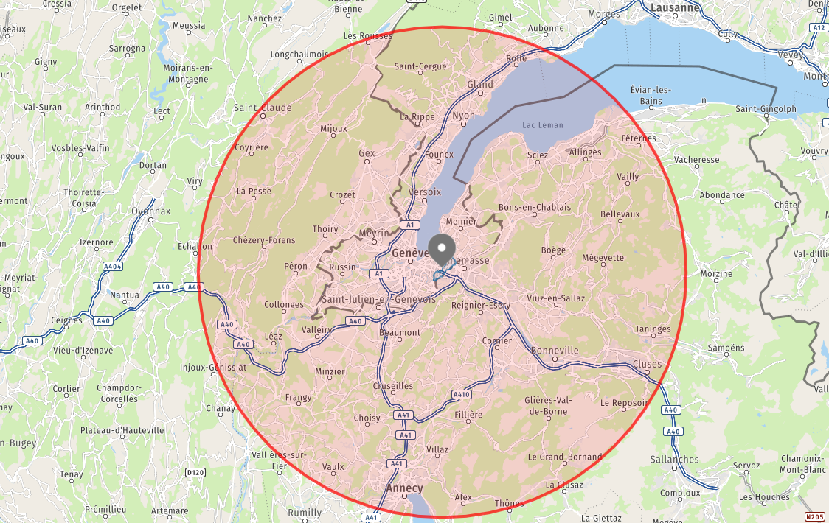**Radius of 35 km around Thonex**

**Sources and Methodology will have to be explained below :**

* **From where do you get your sources and how did you manage to get them :**
* **Why did you decide to present this information rather than others :**